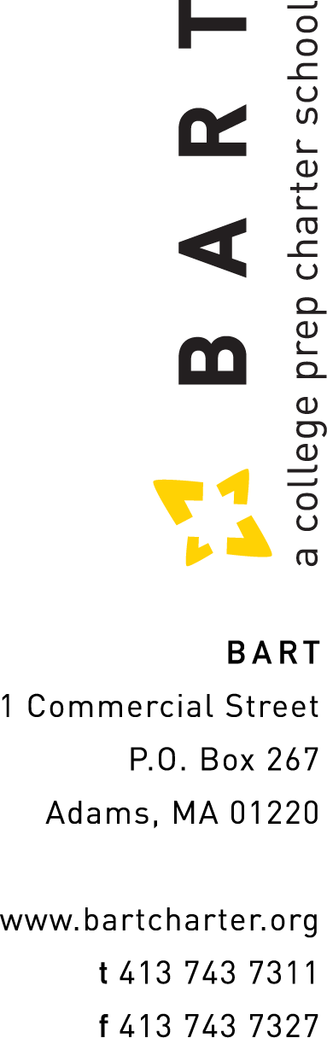
(redacted name and address)

April 16, 2021

RE: FY 2022 Employment Offer Letter

Dear (redacted):

I am pleased to extend our offer of continued employment for you with the Berkshire Arts & Technology Charter Public School. Listed below are the items related to your employment:

Job Title: Executive Director
Start Date: July 1, 2021
Employment Status: Full Time, Exempt
Salary: $(redacted) * to be updated per Board review

This agreement is for the fiscal year July 1, 2021 to June 30, 2022. Your assignment will end on June 30, 2022 unless specifically renewed, in writing, for the next fiscal year.

It is important to note that neither this document, nor any other written or verbal communication, should be construed as creating a contract for employment or a warranty of benefits for any particular period of time, nor does it change the “at will” employment relations between Berkshire Arts & Technology Charter Public School and any of its employees. This means that employees have the right to terminate the employment relationship with Berkshire Arts & Technology Charter Public School at any time, with or without notice, for any reason. Berkshire Arts & Technology Charter Public School has the same right to terminate the employment relationship at any time, with or without notice, for any reason not prohibited by law.

We are excited to have you continue on the team at Berkshire Arts & Technology Charter Public School returning with us all to in-person teaching in the new school year. If the information stated in this letter is correct and if you find the benefits and policies acceptable please sign and date below and return to me as soon as possible. If you have any questions at any time, please feel free to contact me.

Sincerely,

Gina Puc
Chair, BART Board of Trustees

Employee Signature: _______________________________________

Date: ____________

